**4: Docker Installation**

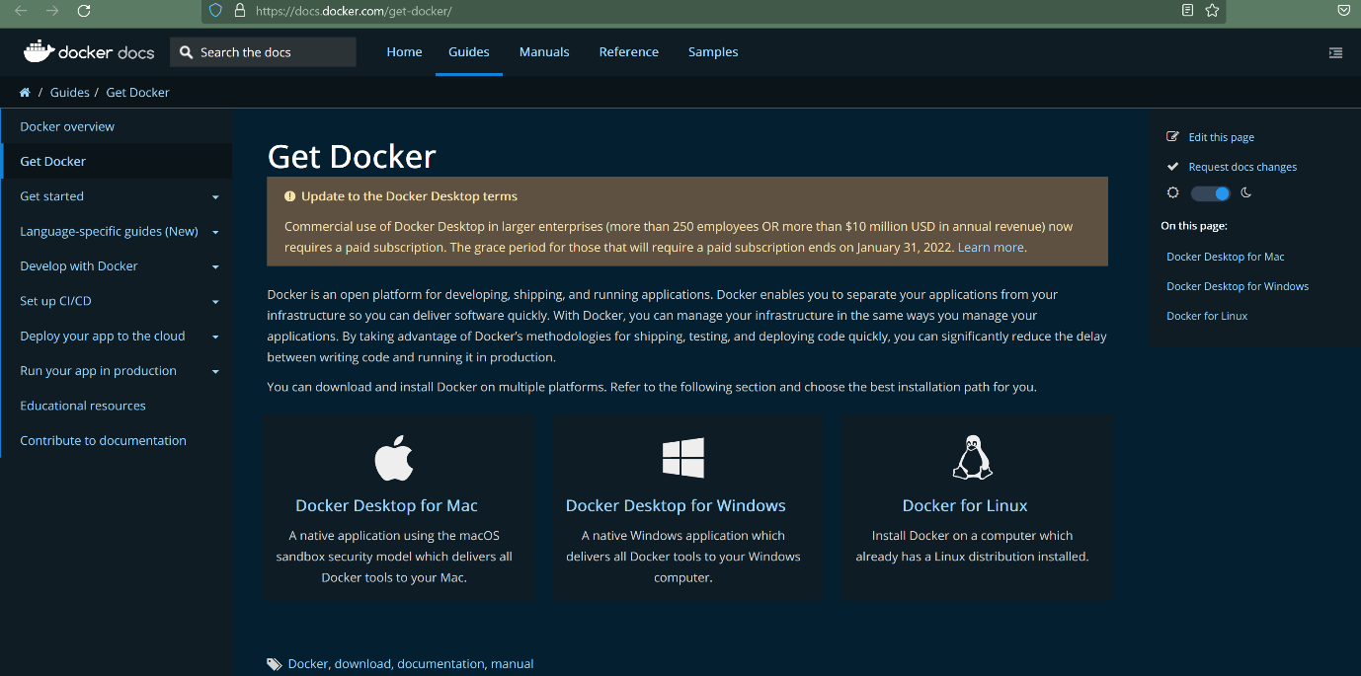

--- [**https://docs.docker.com/install/**](https://docs.docker.com/install/) **-** this is the official page of docker and here you will find the complete documentation of docker installation on different environments.

**Docker Desktop on Windows**

--- https://docs.docker.com/docker-for-windows/

**Docker Desktop on MAC**

--- https://docs.docker.com/docker-for-mac/

**Troubleshooting Docker Desktop issues on MAC**

--- Docker Desktop on mac has an issue with MAC osxkeychain

--- To fix it perform the below steps.

--- Pre-requisite: Refer below link for additional understanding

--- **https://medium.com/@dakshika/error-creating-the-docker-image-on-macos-wso2-enterprise-integrator-tooling-dfb5b537b44e**

**Docker Desktop changes**

--- **Open Docker Desktop --> Preferences**

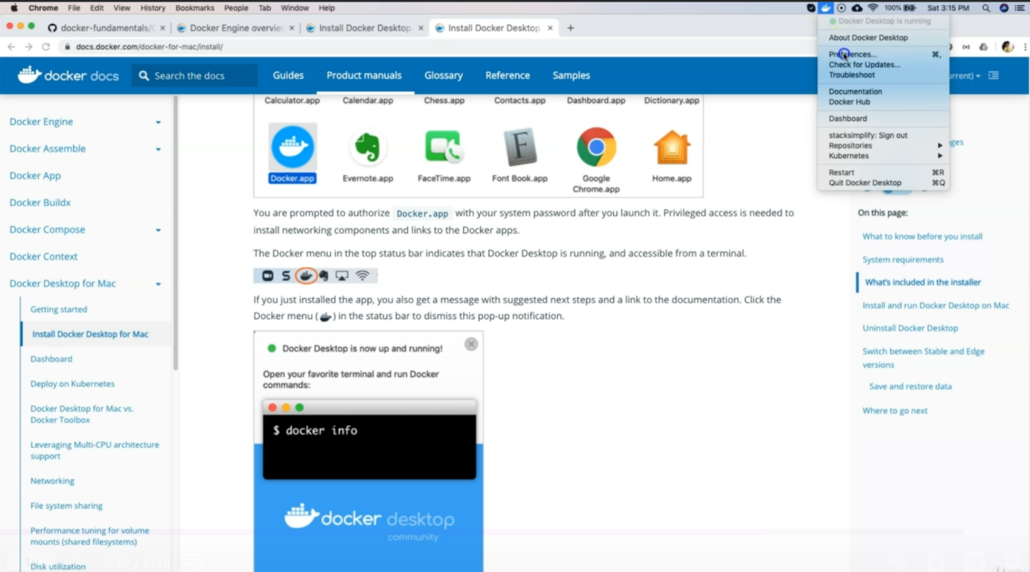

--- click on the preference option.

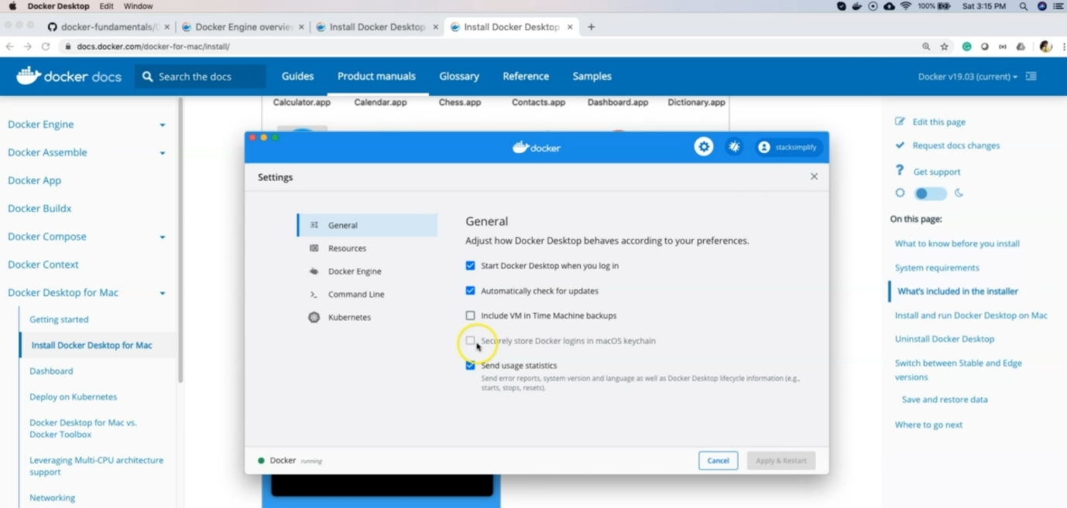

--- **note** - Uncheck the option named Securely store Docker logins in macOS keychain

**Go to config.json file in .docker folder**

--- Sample Reference Location:

--- **/Users//.docker/config.json**

--- **~/.docker/config.json**

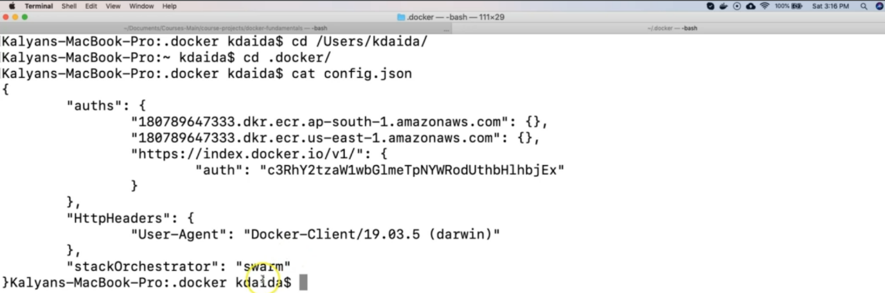

--- **note** - Remove the line **“credSstore” : “osxkeychain”,** in config.json. I already removed the key and value so that is why you are not seeing that here.